**Airlines Passenger Satisfaction Analytics**

**Scope**:

The major goal of this study is to determine the degree of passenger happiness in order to understand the grade of services offered by the airline businesses and the important variables that influence consumer satisfaction.

**Dataset Link**:

[Dataset Search (google.com)](https://datasetsearch.research.google.com/search?src=2&query=Airlines%20Customer%20satisfaction&docid=L2cvMTFqbnlxN3NqMQ%3D%3D)

**Data Context:**

|  |  |
| --- | --- |
| **Variable** | **Meaning** |
| **Gender** | Gender of the passengers (Female, Male) |
| **Customer Type** | The customer type (Loyal customer, disloyal customer) |
| **Age** | The actual age of the passengers |
| **Type Of Travel** | Purpose of the flight of the passengers (Personal Travel, Business Travel) |
| **Class** | Travel class in the plane of the passengers (Business, Eco, Eco Plus) |
| **Flight Distance** | The flight distance of this journey |
|
|
|
|
| **Inflight Wifi Service** | Satisfaction level of the inflight wifi service (0:Not Applicable;1-5) |
| **Departure/ Arrival Time Convenient** | Satisfaction level of Departure/Arrival time convenient |
| **Ease of Online Booking** | Satisfaction level of online booking |
| **Gate Location** | Satisfaction level of Gate location |
|
|
|
| **Food & Drink** | Satisfaction level of Food and drink |
| **Online Boarding** | Satisfaction level of online boarding |
|
|
|
| **Seat Comfort** | Satisfaction level of Seat comfort |
| **Inflight Entertainment** | Satisfaction level of inflight entertainment |
| **On-board Services** | Satisfaction level of On-board service |
|
|
|
| **Leg Room Services** | Satisfaction level of Leg room service |
| **Baggage Handling** | Satisfaction level of baggage handling |
| **Check-in Services** | Satisfaction level of Check-in service |
| **Inflight Services** | Satisfaction level of inflight service |
| **Cleanliness** | Satisfaction level of Cleanliness |
| **Departures Delay in Minutes** | Minutes delayed when departure |
|
|
|
| **Arrival Delay in Minutes** | Minutes delayed when Arrival |
|
|
|
| **Satisfaction** | Airline satisfaction level(Satisfaction, neutral or dissatisfaction) |

How Airlines Passenger Satisfaction does works/ helps in Airlines industry?

It explores the elements that contribute to airline satisfaction by coming up with marketing initiatives that involve identifying possibilities and problems in the airline sector. By examining customer satisfaction for a number of a logically valid market segments identified by using the survey method, which takes into account the multi-step nature of the airline choice process, it also aids in evaluating previous work actions, compares past performance with the real objective of the airline industry, and focuses on developing a better idea for the future to improve service quality.

**Data Collection/ Extract:**

Data are essential to this investigation. The people who have specific travel experience with a particular airline have provided primary data. The questionnaire primarily asks about psychological and behavioral traits, attitudes and opinions, as well as goals, before moving on to questions about awareness and knowledge.

On a variety of platforms, including cloud storage provided by AWS, Azure, and other database services like SQL, the data can be gathered or stored.

By using Power BI and having a working login and account, we can quickly connect to these different data platforms. Once the connection is made, we may quickly gather or extract the data we require.

**Pre-Processing & Transformation:**

Data pre-processing or transformation is then used to separate the superfluous data from the collected data. The information is then categorized based on the quantity of measurement variables. Numerous techniques can be used to analyze data. In this study, factor analysis is utilized to pinpoint the factors that have the greatest impact on passenger happiness in the airline sector.

If a value is absent from the data, we often replace it using the series mean or the mean of close points for homogeneous data, the median of nearby points for heterogeneous data, and for time series data, we typically use linear interpolation.

Once the data is been processed & transform, it is ready to perform analysis & create visualization reports to finally draft dashboard.

**Data Analysis:**

Depending on how the airline firms are attempting to identify it, there are specific parameters. The likes and dislikes of a passenger may vary depending on a number of factors, including the cost of the flight, the level of service received from the airline, employee behavior, check-in options, cancellation fees, the way complaints are handled, the type of aircraft, etc. The results of this study will aid airline firms in identifying service quality gaps and in future efforts to close them by focusing on the key elements.

By conducting surveys among airline passengers, we are adopting the "Descriptive Research" methodology in this study.

The aim of this study's descriptive research method is to:

1. Identify the traits of a certain client group.
2. Calculate the percentage of customers who exhibit similar behavior.
3. Decide whether to upgrade the services.

This research methodology aids in determining the behavior of the target group of respondents, aids in calculating the percentage of people who share a given viewpoint, and ultimately aids in creating an appropriate forecast to enhance service quality.

**Data Visualization:**

Below is the performed data visualization on the dataset available Airline Passenger Satisfaction from the Dataset-search a research tool of Google. The data visualization is performed on the visualization tool called as Power BI.

The dashboard consist of various visuals that indicates various factors. The dashboard is consist of 5 pages – Summary, Food & Entertainment, Inflight Comfort, Airport Experience & Website Navigation. Each page in dashboard demonstrated different values & insights from the data.

**Summary**:

The Summary page shows visuals on Total Men & Women that have travelled in airlines, Average ratings by customers based on the parameters, Number of satisfied customers by the airlines services, & customer across different class of airlines.

While there is a constant filters set for both the pages which helps in getting the insights based on user’s needs. This filters are based on the travel category of the customer – Business travel & the Economic/ Personal travel.

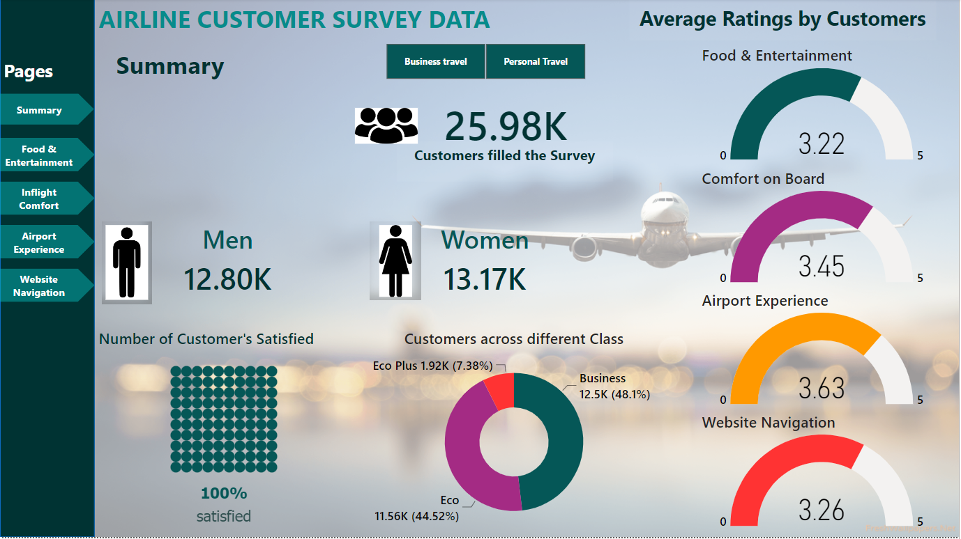

*Image: Summary page of the Airlines Passenger Satisfaction*

**Business Travel (Summary):**

The Business Travel filter in Summary page shows values on the visuals based on the customers that have travelled in business category of the airline. The customers that have travelled in business & have provided with their satisfaction records under satisfaction survey can be seen on the visuals. Different visuals that includes customer satisfaction, total number of men & women that have travelled in business, customers across different class & various parameters in average ratings for different services such as comfort on board, airport experiences, website navigation, etc.

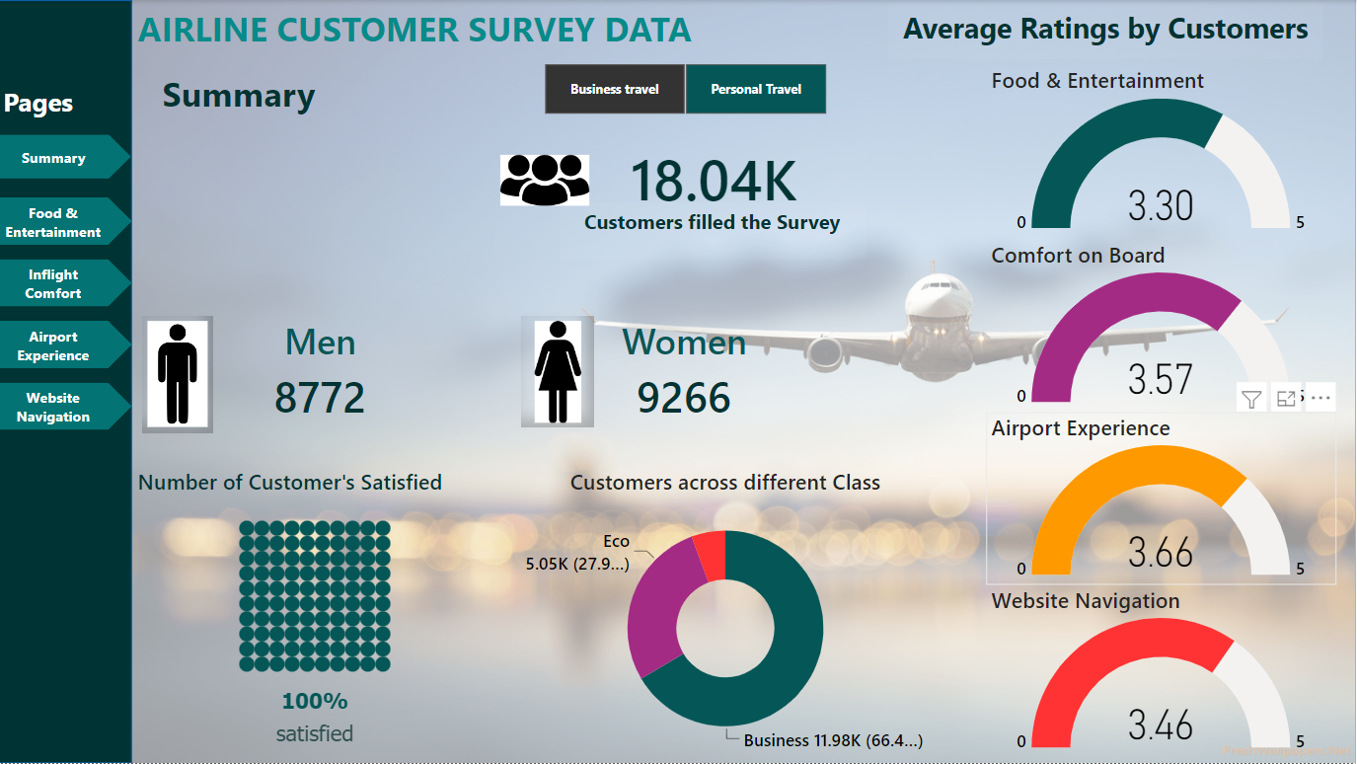

*Image: Business Travel of the Airlines Passenger Satisfaction*

**Personal Travel (Summary):**

The Summary page's Personal Travel filter displays values on the visuals based on clients who have travelled for personal reasons. The pictures show the passengers who travelled in the personal category and who supplied their satisfaction records as part of the satisfaction survey. Customer happiness, the total number of men and women who have travelled for business, consumers from different classes, and numerous metrics in average ratings for various services, such as onboard comfort, airport experiences, website navigation, etc., are included in various visuals.

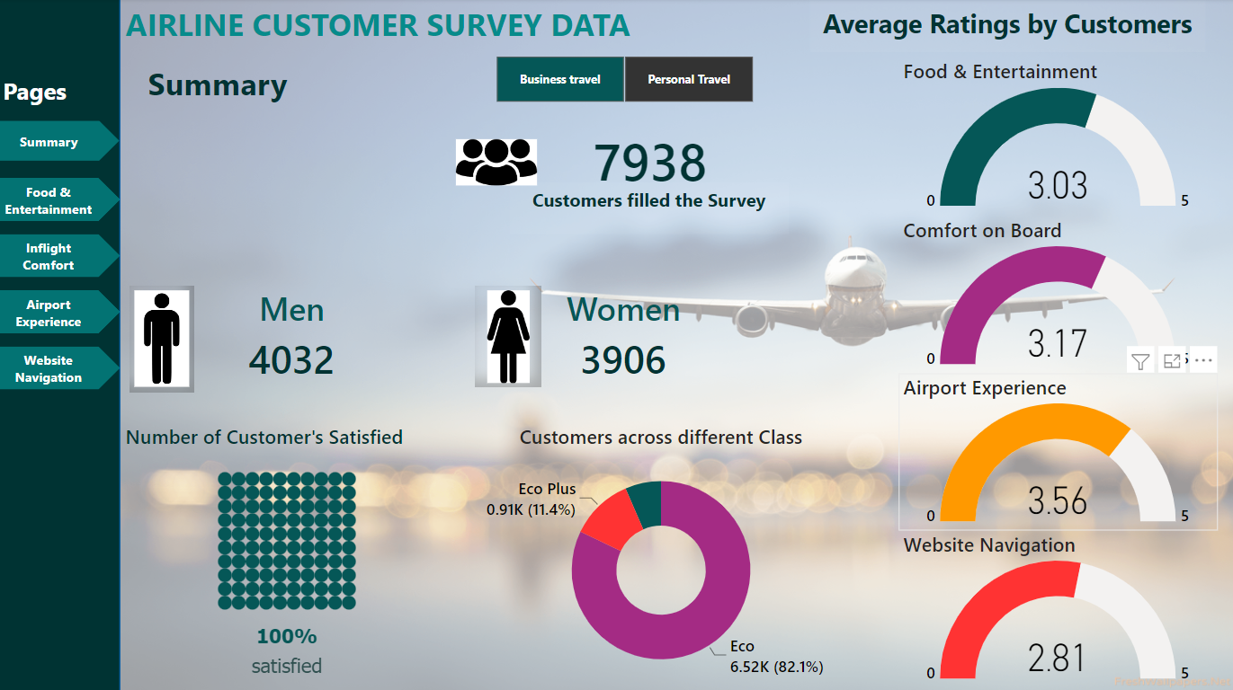

*Image: Personal Travel filter on Airline Passenger Satisfaction*

**Food & Entertainment**

The below visualization helps in understanding the number of passengers travelled in the airlines. The visuals depicts the report on various factors such as WiFi, Inflight Entertainment, Food & Drink & Inflight Services. There are also various buttons to check the report based on the required data field. The class filters helps in knowing the visuals or report based on each class of the passengers. While the two buttons on the top right helps in visualizing in details of the visual & also, in comparison.

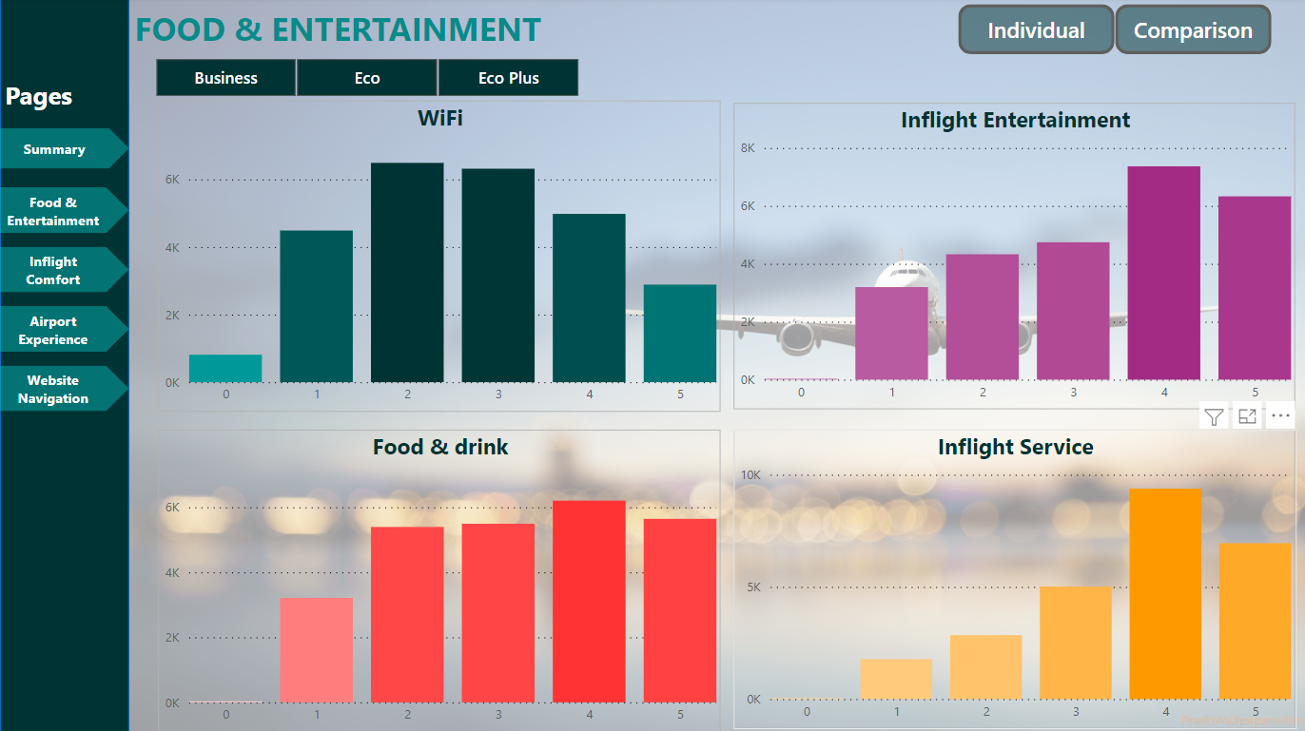

*Image: Visual from Food & Entertainment page*

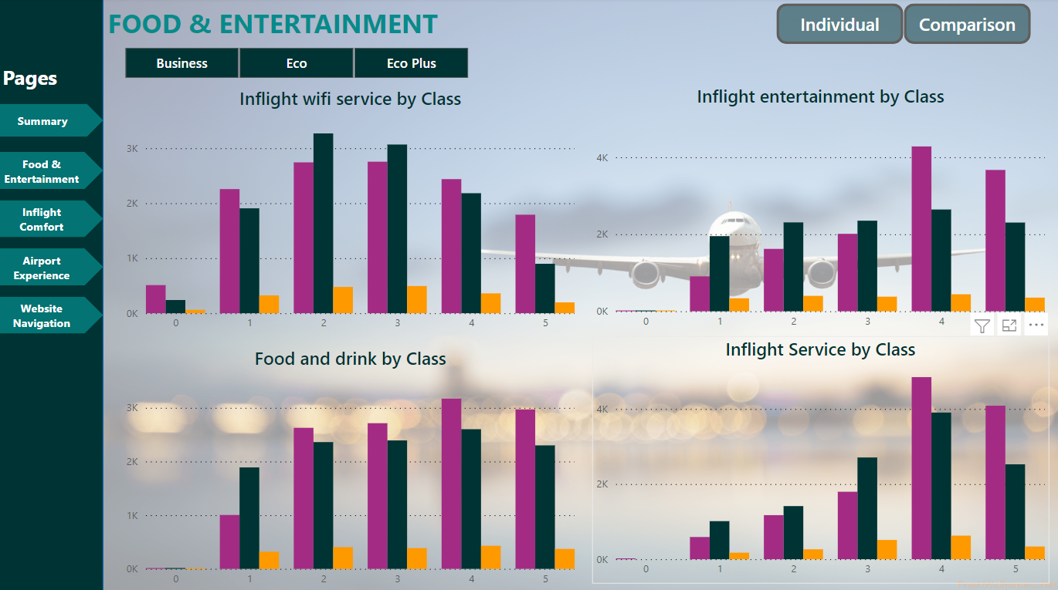

*Image: Visual from Food & Entertainment page - Comparison*

**Inflight Comfort:**

Understanding the values in the image below and the characteristics included in Inflight Comforts helps one comprehend the number of people transported by the airlines. The graphics present a report on a number of issues, including Cleanliness, Leg Room, Onboard Services, and Seat Comfort. Additionally, there are numerous buttons to examine the report depending on the necessary data field. The class filters make it possible to view or understand reports or visualizations according to each passenger class. While the two buttons in the upper right aid with comparing as well as visualizing the image in detail.

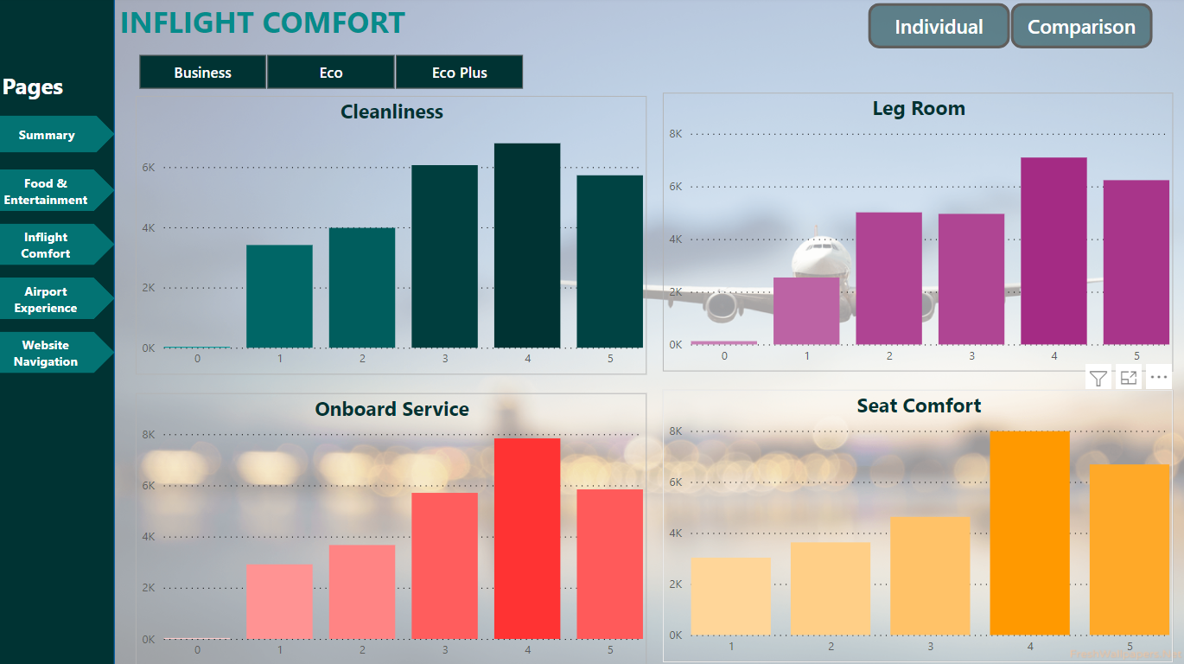

*Image: Visual from Inflight Comfort*

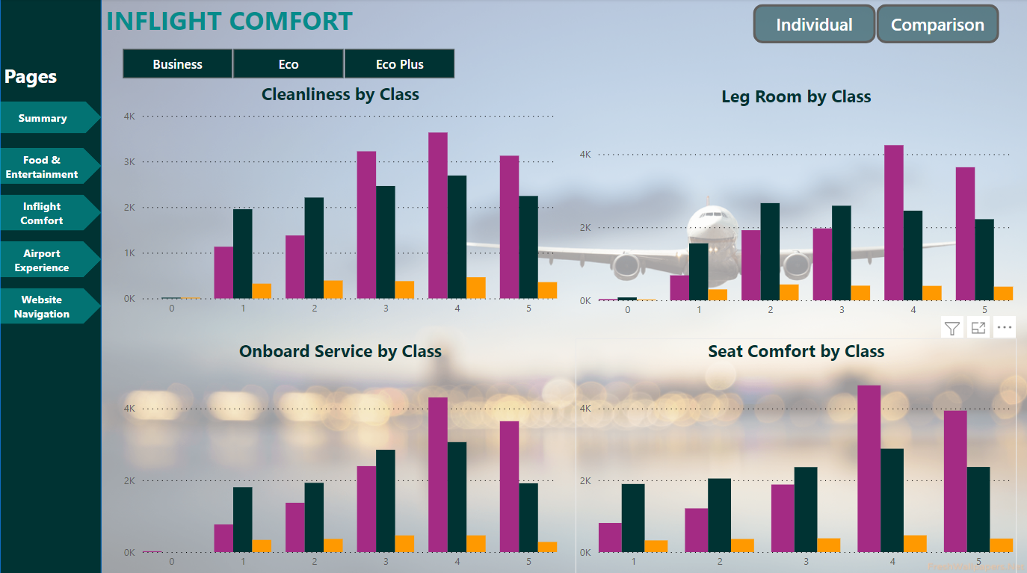

*Image: Visual from the Inflight Comfort - Comparison*

**Airport Experience:**

The below visualization helps in understanding the number of passengers travelled in the airlines & filled the survey that included the category – Airport Experience. The visuals depicts the report on various factors such as Baggage Handling, Gate Location, Check-in Services & Time Convenient. There are also various buttons to check the report based on the required data field. The class filters helps in knowing the visuals or report based on each class of the passengers. While the two buttons on the top right helps in visualizing in details of the visual & also, in comparison.

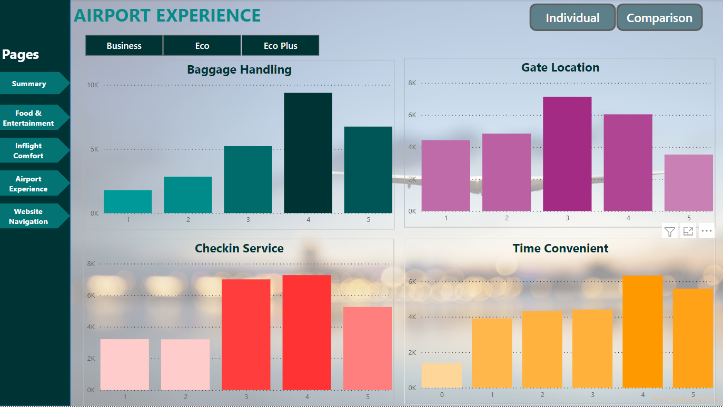

*Image: Visual from the Airport Experience*

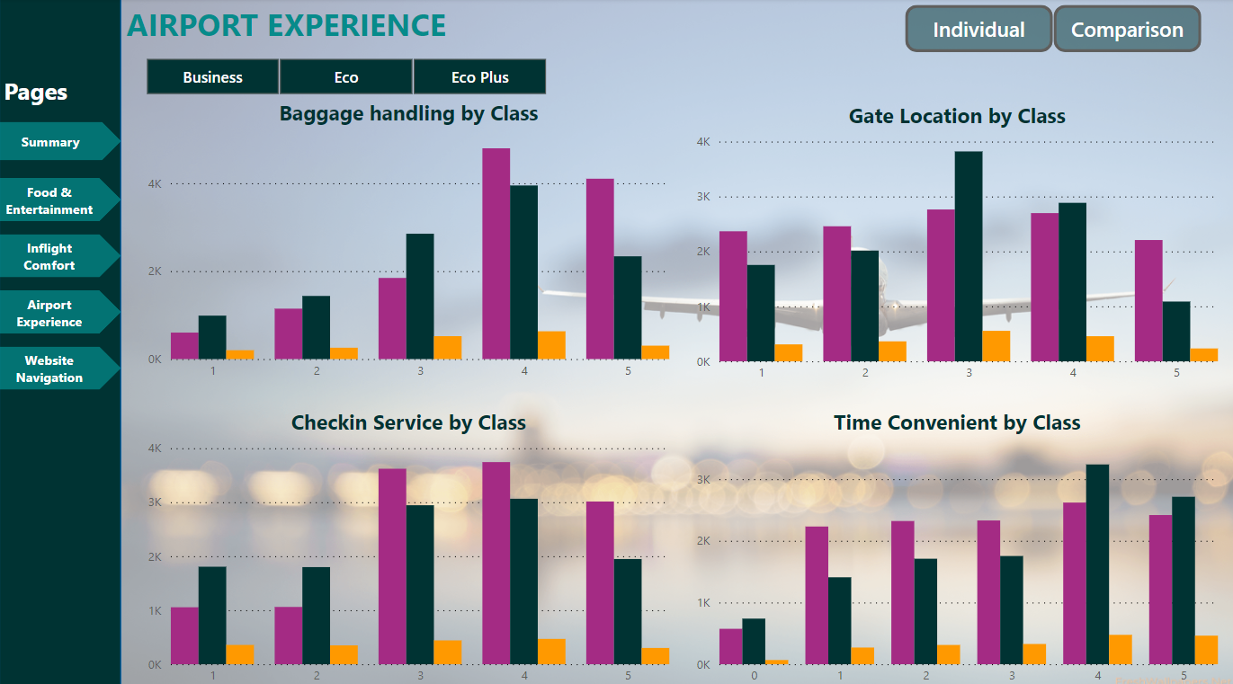

*Image: Visual from the Airport Experience - Comparison*

**Website Navigation:**

Understanding the number of passengers who used the airlines and responded to the survey with the Website Navigation category is made easier with the help of the visualization below. The images illustrate the report's analysis of several criteria, including online booking and online booking ease. Additionally, there are numerous buttons to examine the report depending on the necessary data field. The class filters make it possible to view or understand reports or visualizations according to each passenger class. While the two buttons in the upper right aid with comparing as well as visualizing the image in detail.

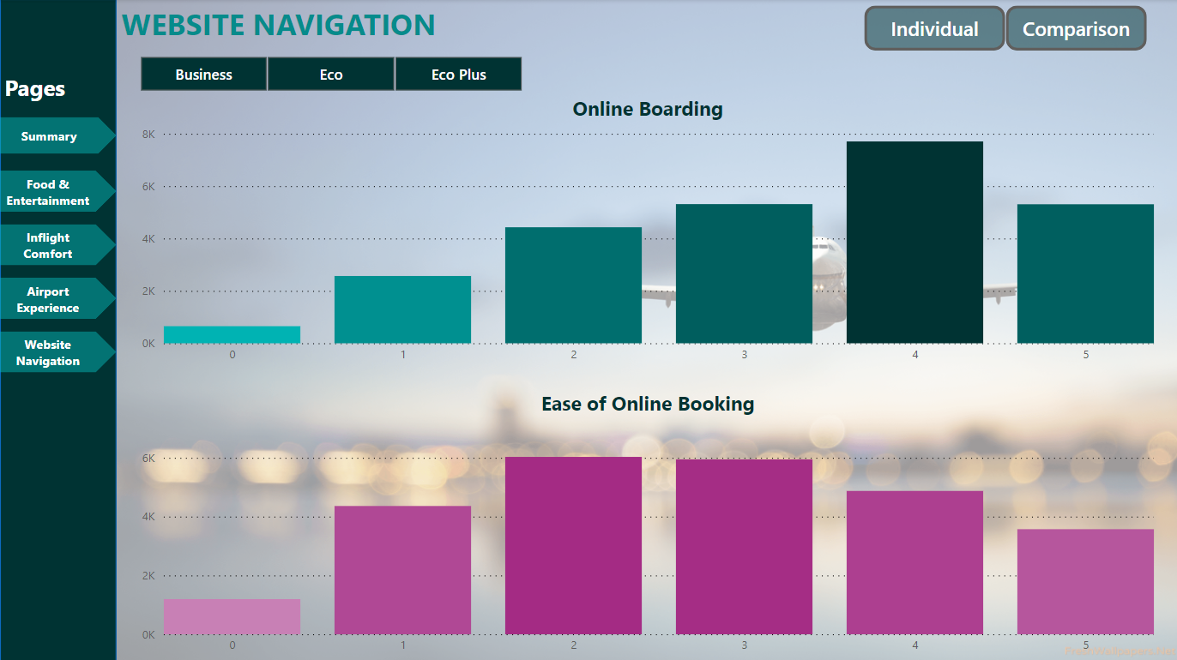

*Image: Visual from the Website Navigation*

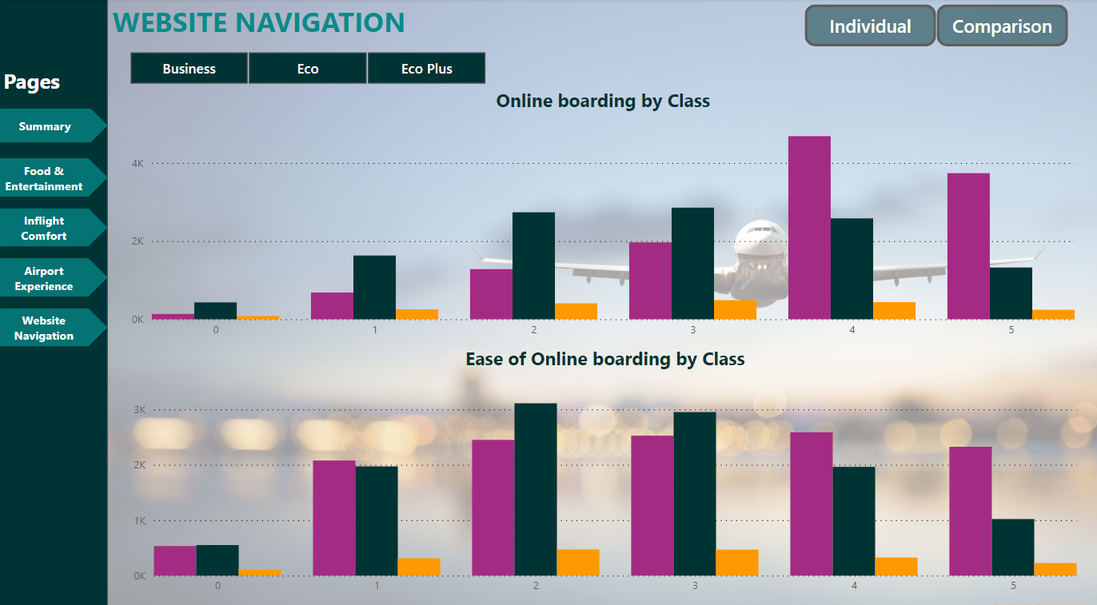

*Image: Visual from the Website Navigation - Comparison*

Conclusion:

Investigating the effect of airline service quality on customer satisfaction was the aim of this study. The company's goal of giving passengers better services, and the management in particular, bears much of the blame for this. The impact of airline service dimensions on passenger satisfaction intentions and airline image was shown to be significant and favorable. Passenger dissatisfaction might cause the organization serious problems. If the customers are not pleased, the business cannot prosper. As a result, it is the company's job to meet the expectations of the customers. Customers will get dissatisfied if their expectations are high and their actual experience falls short of those expectations.